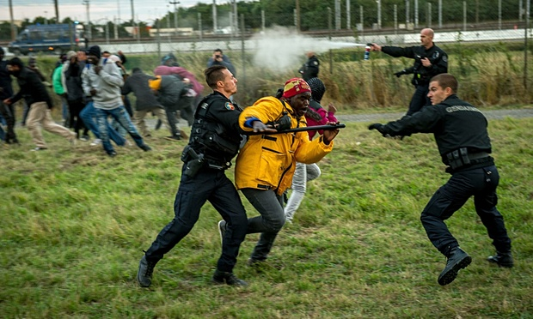
Europe could solve the migrant crisis – if it wanted
Daniel Trilling
We face a political choice between treating
‘How we respond will most likely come down to whether we see these people as refugees in need of protection, or as people who are playing the system for a better deal. But the uncomfortable truth is that they are both.’ Photograph: Philippe

It takes about two hours to burn off your fingerprints. You find a piece of metal pipe, stick it in the fire until the end goes red hot, then rub the tips of your fingers quickly but firmly along the glowing end – and repeat. Such is the body’s ability to repair itself, the damage only lasts a few days; but long enough to make it impossible for border police to enter your details into Eurodac, the European Union’s fingerprint database for asylum seekers.

This technique, described to me recently by a Sudanese refugee who spent five months living rough in Calais last year, was an attempt to dodge the EU’s Dublin regulation, which insists that refugees claim asylum in the first member state they set foot in. It’s just one example of the desperate and self-destructive measures taken by the many thousands of people who come to Europe as refugees, then spend months or years travelling the continent in search of a new home. This week a Guardian reporting team brought many other such experiences to life in a vivid portrait of the Calais camps; the death of a man by the ferry port on Tuesday further underlined the dangers the migrants face.

Yet it often seems as if these stories are as likely to evoke disgust as they are sympathy. These people are living lives that the majority of British residents will find it difficult to imagine. Reading about them might make us more likely to support liberal immigration policies – but then again, it might provoke us to dismiss them as “cockroaches”, or a “swarm of people”, as David Cameron did today. For every reader who is shocked by Monday’s revelation that HMS Enterprise, sent by Britain to support search-and-rescue operations in the Mediterranean a month ago, has not yet saved a single life, there could be another who thinks “good, we don’t want any more migrants coming to Europe”.

How we respond will most likely come down to whether we see these people as refugees in need of protection, or as people who are playing the system for a better deal. But the uncomfortable truth is that they are both. The Sudanese I met, for instance, were for the most part refugees from the massacres in Darfur, a conflict that drew the global media’s attention a decade ago but has since been ignored. But by the time they reached Calais, they had been through several European countries where there was no immediate threat to their lives. Having first arrived in Italy or Greece, they had left and were trying to sneak into the UK – some, hedging their bets, were applying for asylum in France at the same time.

Refugees from many countries – not just Sudan but Syria, Eritrea, Afghanistan and beyond – are taking clandestine journeys across Europe in search of a country that will give them the chance to rebuild their lives. Living in Britain and watching what unfolds in Calais – such as the revelation that in recent days there have been 1,500 attempts by migrants to enter the Channel tunnel – it can seem as if they’re all heading here, but in reality Britain ranks mid-table in the proportion of asylum claims it receives relative to population. The number of refugees at Calais has grown because the number of refugees in Europe as a whole has grown. For the most part, their journeys pass unseen, until they hit a barrier – the English Channel; the lines of police at Ventimiglia on the Italy-France border; the forests of Macedonia – that creates a bottleneck and leads to scenes of destitution and chaos.

The political rhetoric that surrounds these migrants makes it harder to understand why they take such journeys. Often when government ministers are called on to comment, they will try to make a distinction between refugees (good) and “economic migrants” (bad). But a refugee needs to think about more than mere survival – like the rest of us, they’re still faced with the question of how to live.

What they find when they reach Europe is a system best described as a “lottery”. In theory the EU has a common asylum system; in reality it varies hugely, with different countries more or less likely to accept different nationalities and with provisions for asylum seekers ranging from decent homes and training to support integration in some countries, to tent camps or detention centres, or being left to starve on the street, in others.

Countries that bear the brunt of new waves of migration, such as Italy, Bulgaria or Greece, find little solidarity from their richer neighbours. The EU spends far more on surveillance and deterrence than on improving reception conditions. For as long as these inequalities continue, refugees will keep on moving.

This is a crisis of politics as much as it is one of migration, and I think it will develop in one of two ways. Either Europe will continue to militarise its borders and squabble over resettlement quotas of refugees as if they were toxic waste; or we will find the courage and leadership to create a just asylum system where member states pull together to ensure that refugees are offered a basic standard of living wherever they arrive. The first option, though alluring to many, will only intensify the chaos it’s supposed to protect us from: we put up a fence at Greece’s land border with Turkey, so refugees take to the Mediterranean instead. Britain and France accuse each other of being a soft touch on asylum seekers, so they allow the situation in Calais to fester. For as long as refugees are treated as a burden, they will be the target of racism and violence.

The second option requires a deeper, more difficult conversation about the EU and whom it exists to benefit. Europe prides itself on having taken down internal borders but is this maintained in the interests of capital or of people? Does anti-immigration sentiment build because politicians are unwilling to address inequality, or to address the feeling of disenfranchisement among their own voters?

Nevertheless, a solution is within our reach. From the volunteers who visit detainees in British immigration prisons and the No Borders activists in Calais who help migrants find safe, empty buildings to live in, to the support groups that have sprung up in Italy and Greece to help the new arrivals, everyday solidarity exists, and can be built on. Only a small proportion of the world’s refugees reach this continent – over 85% are hosted in developing countries – and we have the resources to help them. Whether it happens or not is our choice.

Article Available at:

http://www.theguardian.com/commentisfree/2015/jul/31/europe-migrant-crisis-political-choice-toxic-waste-sanctuary

